GE Healthcare

1.5T MSK Extreme® Planned Maintenance Guide

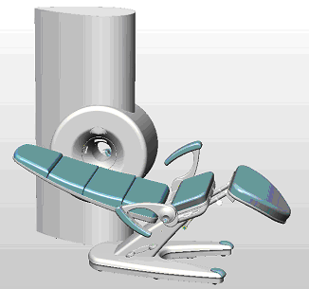

DOC0922905

Rev 5.0
2014, General Electric Company, All Rights Reserved.

1.5T MSK Extreme Planned Maintenance

Revision History

Revision Date Changes

1.0 March, 2011 Initial conversion of 5000-9306-000 to GE format

2.0 August, 2012 Added information about how to test leg stability. Added note regarding brake pad wear to the Break Pads section of Chapter 3.

3.0 July, 2013 Added a bulleted item to the Gradient Chiller section of Chapter 3 describing how to verify there are no leaks in any of the hose connections. This text was validated when this information was included in the Optima PM Guide.

4.0 May, 2014 Added JDTA changes:
Added location of error log file, service tools executable, and MMUlog.csv file Combined Magnet Center Frequency section with 180 mm RF Coil section. Edited laser light position in Laser Alignment Light section.
Removed Prescription Parameters from RFI Interference section.
Changed floppy disk to USB stick in Backing Up Configuration Files section. Added Replacing the K-O Concepts Chiller Fan section to Chapter 3.
The information in this Planned Maintenance guide is identical to information added to the Optima MR430s Planned Maintenance Guide (DOC0797553) which was validated using DOC1539818.
Signatures in DOC0591190 are archived in the service validation binder.

5.0 July, 2015 Added steps 22 and 23 for checking the software revision and the Host Computer Battery under the section for ‘Initial Inspection’

1.5T MSK Extreme Planned Maintenance
Table of Contents
Revision History 2
List of Figures 3
- Document Overview
Scope and Objective 4
Contents of the Document 4
Navigation 4
Links 4
Bookmarks 4
Switching Between Documents 4
Conventions 4
Text Conventions 4
Safety Hazard Alerts 5
Electrical Safety Symbols 5
Safety Considerations 5
Trademarks 6
- Maintenance Overview
Section Contents 8
Maintenance Interval 8
Responsibilities 8
Applicable Documents 8
Industry Standards 8
Internal GE Documents 8
Sumitomo Documents 8
Test Requirements 8
Test Equipment Required 8
Test Conditions 8
Visual and Mechanical Inspection 9
Reporting 9
Data Sheet 9
Initial and Final Entries 9
Pass and Fail Assessments 9
Comments 9
- Maintenance Procedures
Overview 10
Initial Inspection 10
Installing Service Software 11
Gradient Amplifier Calibration 12
Linear Gradients 12
Magnet Center Frequency Initial Value 14
Shimming 14
180mm RF Coil 15
123mm RF Coil 15
Other RF Coils 16
Magnet Monitoring Unit 16
Magnet Monitoring Functions 16
MMU Remote Functions 17
Helium Compressor 18
Gradient Chiller 18
Replacing the K-O Concepts Chiller Fan 19
Patient Chair 19
Hydraulic Systems and Levers 19
Levers 19
Gas Spring 20
Testing Gas Spring Operation 20
Leg Support 21
Testing the Operation of the Leg Support 21
Leg Stability 21
Testing Leg Stability 21
Noise Reduction 21
Scuff Marks 22
Brake Pads 22
Brake Adjustments 22
Caster Inspection 23
General Inspection 23
Magnet Covers 23
Laser Alignment Light 23
RF Interference 23
Cryogen Vent Inspection 24
Image Quality 24
Backup Configuration Files and Magnet History
File and Remove Service Software 25
Backing up Configuration Files 25
Backing up Magnet History file 25
Removing Service Software 25
Reporting 25
Index 27

1 of 27

1.5T MSK Extreme Planned Maintenance

This page left blank intentionally

2 of 27

1.5T MSK Extreme Planned Maintenance List of Figures

List of Figures

Acrobat Reader Back Button 4
Data Sheet Heading 10
Initial Inspection Table 10
Magnet Helium Level & Temperatures Table 10
Gradient Amp Calibration Table 12
Meas tab on Image Viewing Page 13
Shim Table 14
Shim Ellipsoid Settings 14
Shim Ellipsoid Error 14
180mm RF Coil Table 15
123mm RF Coil Table 15
Magnet Helium Level & Temperatures Table 16
Miscellaneous Table 17
Magnet Pressure Regulator Table 17
CasWin Dialog Window 17
Helium Compressor Table 18
Miscellaneous Table 18
Front of K-O Concepts Chiller 19
Patient Chair Controls 19
Patient Chair Table 20
Limit Screw. 20
Hydraulics, Right Side View 20
Hydraulics, Left Side View 21
Location of Four Bushings 21
Leg Support Bumpers. 21
A-Frame Brake Assembly and Brake Pads 22
Brake Adjustments 22
Miscellaneous Table 23
Image Quality Table 24

3 of 27

1 Document Overview

Scope and Objective
This document describes the tests and inspections that comprise the 1.5T MSK Extreme® planned maintenance (PM) program. The procedures described in the Planned Maintenance Guide verify proper operation of the imaging system, inspect mechanical parts that might be subject to excessive wear, and inspect and clean any air filters in the system.

Contents of the Document
This document includes the following sections:
    - Document Overview – This chapter, which describes the document.
    - Maintenance Overview on page 8 describes the interval, responsibilities, requirements, and reporting method of planned maintenance.
    - Maintenance Procedures on page 10 contains step-by-step procedures for performing planned maintenance tests and recording the results.

Navigation

Links
Blue text indicates a link to another section or document. Part numbers in blue are links to the related line in the parts list. Clicking the blue text jumps to the indicated place. (The blue text at the beginning of this item is not a link.)
All listings in the Table of Contents and in the Index are links to the named item (these links are not blue). Clicking a listing in the Table of Contents or in the Index jumps to the listed page.

Bookmarks
The Bookmarks tab at the top left corner of the Acrobat screen provides a hierarchy of headings in the document that works like the Windows explorer. Clicking a heading in the bookmarks list opens the page that contains the heading. To open or close the bookmarks display, click the Bookmarks tab. Closing the bookmarks display allows a larger display area for the document.

Switching Between Documents
Figure 1-1 Acrobat Reader Back Button

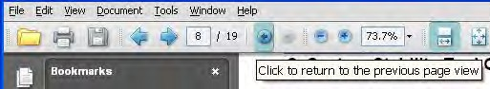After making a jump to another PDF document or to another location in the Planned Maintenance Guide, use the back (left arrow) button in the Acrobat Reader tool bar to jump back to the original location.
After jumping to a non-PDF document, press Alt-Tab to return to the Planned Maintenance Guide.

Conventions
The conventions described below are used throughout the 1.5T service documents.

Text Conventions
The following text conventions indicate on-screen features and controls, and emphasize important operations:
    - References to on-screen text and controls are in a special font, to distinguish them from the normal flow of text.
Example: When Clone completed Successfully appears, remove the floppy and CD-ROM disks. In the example, “Clone completed Successfully” is text in the computer display.

- of 27

    - When a reference to on-screen text includes an undefined variable, the variable is in italics, between brackets.
Example: No connection to Server <MSK Extreme 1.5T:[database number]>
In the example, “[database number]” refers to a value that is not specified. The rest of the example is the same as the display text.
    - In some procedures, the most significant words in a step are in bold type. If the words refer to an on-screen feature, they are in the special font in bold.
Example: On the Start Copying Files window, click Next>.
In the example, the N in “Next” is underlined because it is underlined in the display.

Safety Hazard Alerts
Three hazard classifications are used in this document:

Alert | Circumstance for Use
 | Danger indicates an imminently hazardous situation, that, if not avoided, will result in death or serious injury. Danger is limited to extreme situations.
 | Warning indicates a potentially hazardous situation, that, if not avoided, could result in death or serious injury.
 | Caution indicates a potentially hazardous situation, that, if not avoided, may result in moderate to minor injury.

Electrical Safety Symbols
The 1.5T MSK Extreme system is a Class 1, type B applied part, rated for continuous operation. This device classification refers to the level of protection provided against electrical shock to the parts are in contact with the patient.

The symbol shown to the left, where displayed, indicates that there are dangerous voltages accessible beyond that point. Access may pose a safety risk and should only be done by qualified service personnel.

The symbol shown to the left indicates a safety warning and that accompanying documents should be consulted.

 The symbol shown to the left indicates that this terminal is used for potential equalization.
Notes contain important information that can help you perform service operations. A note can describe a special condition you may encounter, can describe actions that simplify your work, or can alert you to other actions that create unnecessary work.

Safety Considerations
For detailed safety information relating to the 1.5T MR imaging system, refer to the Safety Guide (DOC0933218). The following warnings apply to procedures in the PM Guide:

The 1.5T MR System creates a strong magnetic field, which can turn metal objects into missiles. To prevent personal injury and equipment damage, do not bring ferrous tools or other objects that might
be affected by the magnetic field into the scan room.

- of 27

Trademarks
Windows XP, Windows NT, and Microsoft Excel are registered trademarks of Microsoft Corporation. Silhouette is a registered trademark of Cedara Corporation.
All other brand names and product names used in this document are trademarks, registered trademarks, or trade names of their respective holders.

- of 27

This page left blank intentionally.

- of 27

1.5T MSK Extreme Planned Maintenance

Maintenance Overview

Section Contents
This section of the Preventive Maintenance Guide includes the following topics:
    - Maintenance Interval on page 8
    - Responsibilities on page 8
    - Applicable Documents on page 8
    - Test Requirements on page 8
    - Visual and Mechanical Inspection on page 9
    - Reporting on page 9

Maintenance Interval
Maintenance procedures should be performed at every site at three month intervals.

Responsibilities
It is the responsibility of the Field Service Engineer (FSE) to perform the PM procedures and return the completed data sheet as part of the related Request for Service (Dispatch).

Applicable Documents

Industry Standards
None applicable.

Internal GE Documents
    - 1.5T PM Data Sheet (DOC0922906)
    - 1.5T Installation Guide (DOC0922902)
    - Magnet Shimming Guide (DOC0797561) (Applies to both Optima 1.5T MR430s and 1.5T MSK Extreme products.)
    - 1.5T Site Planning Guide (DOC0922898)
    - MR Safety Guide (DOC0933218)

Sumitomo Documents
    - CD6503-043C Cryocooler Specification Model SRDK-305N2-A31C (DOC0798957)
    - CD6503-044C Cryocooler Specification Model SRDK-305N2-A31D (DOC0798956)
    - CD32ZZ-114E SRDK-305 Series Cryocooler Operation Manual (DOC0798958)
    - CD32ZZ-116E Technical Instruction CNA-31C Compressor Unit (DOC0798955)
    - CD32ZZ-117D Technical Instruction CNA-31D Compressor Unit (DOC0798954)

Test Requirements
Perform the procedures in the same order that they are presented here.

Test Equipment Required
The test equipment required for this procedure varies with the particular procedure or test. These items are listed individually in each Procedure subsection, where applicable.

Test Conditions
The tests must be performed in the clinical configuration, after the site meets the requirements listed in the 1.5T MSK Extreme Pre- Installation Guide. At least six hours should be scheduled to complete this procedure; conditions may require more time.

  - of 27

1.5T MSK Extreme Planned Maintenance

It is not a requirement to correct all the faults discovered during PM. However, all corrective work must be clearly noted in the PM Test Data Sheet, and uncorrected faults must be referred to service management.

Visual and Mechanical Inspection
Some system components require visual or mechanical inspection. This is called out for each component where applicable.

Reporting
Maintenance test results must be entered in the PM Data Sheet, which is a Microsoft Excel® spreadsheet. When the maintenance is complete, email the completed data sheet file to: SpecialtyMRmsk@ge.com.

Data Sheet
The data sheet is an Excel spreadsheet template (with a .xlt extension). When the template is opened with Excel, it opens as a new spreadsheet (with a .xls extension). This new spreadsheet must be named and saved. Because the spreadsheet makes calculations automatically based on values entered in some of the cells, values must be entered directly in the spreadsheet. The data sheet captures both the entered data and the automatic evaluation of that data.

Initial and Final Entries
For tests that require recording a value, two columns are provided in the data sheet. These columns are labeled Initial and Final. The Initial column records the status of a particular parameter when PM is begun. The Final column records the final results after any changes or adjustments are made.

Pass and Fail Assessments
If there are pass and fail criteria for a value, the spreadsheet automatically indicates Pass or Fail in the column headed P/F when the Initial data are entered. Failure usually requires corrective action. When corrective actions are complete, enter the results in the Final column. If the Final value is within specifications, the related cell in the P/F column changes to Pass.

Comments
If changes are made (such as re-shimming or updating gradient calibration factors), use the Comments field to document what actions were taken. If a value was out of specification, a comment must be included regarding the effect of the variance on clinical performance. If, in the opinion of the FSE, there was no significant clinical impact, that should be stated. If the FSE believes there is a resulting effect on clinical performance, the effects should be described briefly.
Example: If the inhomogeneity on the LFOV was 30 ppm, the comment might read “Shim drift, most likely due to room temp variation, resulted in a moderate loss of image definition. Correction to 18 ppm restored normal performance. Recommend HVAC performance review.”

  - of 27

1.5T MSK Extreme Planned Maintenance

Maintenance Procedures

Overview
This chapter includes the following maintenance procedures:
    - Initial Inspection on page 10
    - Installing Service Software on page 11
    - Shimming on page 14
    - 180mm RF Coil on page 15
    - 123mm RF Coil on page 15
    - Other RF Coils on page 16
    - Magnet Monitoring Unit on page 16
    - Helium Compressor on page 18
    - Gradient Chiller on page 18
    - Patient Chair on page 19
    - Magnet Covers on page 23
    - Laser Alignment Light on page 23
    - RF Interference on page 23
    - Cryogen Vent Inspection on page 24
    - Image Quality on page 24
    - Image Quality on page 24
    - Backup Configuration Files and Magnet History File and Remove Service Software on page 25
    - Reporting on page 25

Initial Inspection

Figure 3-2 Data Sheet Heading

- Open the data sheet and save it with the system ID in the file name.
- Record the system ID, the site name, the date, and your name on the heading of the data sheet.
- Review the System Error log, under the MMU status tab, and the C:\MMUlog.csv file to verify that the helium levels and magnet temperatures are being recorded. Check the He level/Magnet Temp Reporting box in the data sheet. Initial Inspection table.

- Review the system error log for indications of system problems. Check the System Error Log Review box in the data sheet Initial Inspection table.
Figure 3-3 Initial Inspection Table

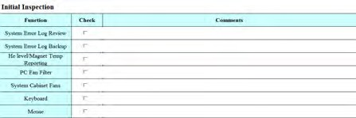

Figure 3-4 Magnet Helium Level & Temperatures Table

- 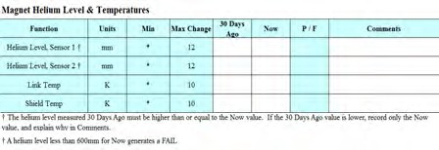Find the magnet helium level for 30 days ago in the MMUlog.csv file, and record the value in the 30 days ago column of the Magnet Helium Level & Temperatures table of the data sheet.
- Find the magnet link temperature for 30 days ago in the MMUlog.csv file, and record the value in the 30 days ago column of the Magnet Helium Level & Temperatures table of the data sheet.
- Find the magnet shield temperature for 30 days ago in the MMUlog.csv file, and record the value in the 30 days ago column of the Magnet Helium Level & Temperatures table of the data sheet.

- of 27

- Log off and log on to Windows as Administrator. Use the password smradmin.
- Click OK.
- Go to the Start menu and select Run…
- In the Run popup window, type cmd.
- When the command window opens, type in net stop css and click OK.
- Open Windows Explorer and navigate to error-log.mdb on the C:\ drive.
- Rename the System Error log with today's date, in the form mmddyy. Example: error-logdb_091704.mdb
- Delete any earlier error logs. Check the System Error Log Backup box in the data sheet Initial Inspection table.
- Type in net start css and click OK.
- Log off and log on as sdc. Use the password adw2.0.
- Examine the PC fan filters. Clean them if necessary. Check the PC Fan Filter box in the data sheet Initial Inspection table.
- Verify that all fans are running (cabinet fans, gradient amplifier fan, PC fans), including the fans at the top of the cabinet. Plan to replace any broken fan as soon as possible. Check the System Cabinet Fans box in the data sheet Initial Inspection table
- Examine the keyboard. Clean it, if necessary. Check the Keyboard box in the data sheet Initial Inspection table.
- Examine the mouse. Clean the mouse, if necessary. Check the Mouse box in the data sheet Initial Inspection table.
- Confirm that the site has the latest Service Pack or Software Revision installed on the system by referring to MR Service Pack Software Matrix, DOC1667089 available from the online documentation library. In the SOFTWARE row, check the box in the data sheet Initial Inspection table.
- Check the battery replacement sticker on the Host Computer. The sticker should be attached to the front of the Host Computer. Batteries should be replaced every 3 years.
- If the date on the battery replacement sticker is within 12 months, order the battery and replace at the next PM. Refer to the SMR Battery Replacement procedure DOC1712419 available from the online documentation library.
- If the Host Computer does not have a sticker, order the battery and replace at the next PM. Refer to the SMR Battery Replacement procedure DOC1712419 available from the online documentation library. Install a sticker on the Host Computer and record the date the battery was replaced.
- In the BATTERY row, check the box in the data sheet Initial Inspection table.

Installing Service Software
Some of the following tasks require special files on the host computer. To install the required software in the host computer:
- Insert the Service Tools CD in the host computer drive.
- In Windows Explorer, navigate to OniSvcToolInstall.exe on the Service Tools CD.
- Double-click OniSvcToolInstall.exe.
- Log off the system and log back in.
The .exe program installs the files on the host computer. It also installs a program for removing the files, OniSvcToolUninstall.exe.

For detailed information on the service tools installer, see Installing and Deleting Service Tools.
When maintenance is complete, you must run OniSvcToolUninstall.exe to remove the service software from the host computer. It is GE policy that all service software must be removed from the host computer before
releasing the system to a customer. Leaving the service files on the host computer allows unauthorized changes to system parameters, and could have serious consequences. As an extra safety precaution, the service tools files will be automatically deleted after 24 hours.

- of 27

Gradient Amplifier Calibration
These procedures confirm calibration of the gradient amplifier with the gradient coil. The procedures use the orientation phantom (Part #2000-0008).

Linear Gradients
Each gradient calibration factor can be set independently. This procedure confirms all three parameters at once, to minimize the number of times you must access the configuration file.
- Open the Config File Editor from the service tools pull-down menu.
- Record the initial values for Grad_Gain X, Grad_Gain Y, and Grad_Gain Z on the data sheet Gradient Amp Calibration table.

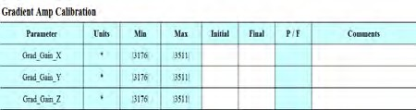Figure 3-5 Gradient Amp Calibration Table

- Insert the 123mm RF coil.
- Place the orientation phantom into the 123mm foam sleeve and center the orientation phantom in the imaging system, with H toward the patient end, A up, and L to the left (when facing the magnet bore from the patient end).
- Set up a study in service mode and select Other as the body part.
- Select the Gradient Gain protocol.
  - Select Manual Prescan.
  - Begin protocol.
  - Do a localizer scan
- Verify that the right and left designations in the plate match the right and left notation in the image. If they do not match, change the sign of Grad_Gain_X.
- Verify that the A/P designation in the plate matches the A/P notation in the image. If they do not match, change the sign of
Grad_Gain_Y.
- Using the axial image as reference, run a sagittal sequence to collect a single slice through the center plastic plate.
- Verify that the H/F designation in the plate matches the H/F annotation in the image. If they do not match, change the sign of
Grad_Gain_Z.

The phantom may have to be slightly offset along the bore for Auto Prescan to work properly.

- From the Manual Prescan page, run Auto Prescan, with Center Frequency method set to Peak, then run Gradient Shim.
- Proceed with the scan.
- When the scan completes, go to the Patient List.
- Select the Gradient Gain Exam.
- Select View.
- From the image viewing page, select the Meas tab. See Figure 3-6.

- of 27

Figure 3-6 Meas tab on Image Viewing Page

- 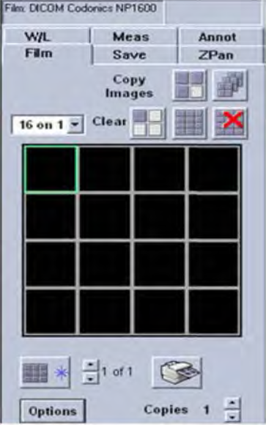Use the line tool to measure the diameter of image #1 in the L/R plane. Calculate the new value of Grad_Gain_X using the following formula:
New value = current value × (actual ID ÷ measured ID) The actual ID is marked on the phantom.
Compare the Grad_Gain_X value to the Initial value on the data sheet Gradient Amp Calibration table.
- Use the line tool to measure the diameter of image #2 in the A/P direction. Calculate the new value of Grad_Gain_Y using the formula in step 17.
Compare the Grad_Gain_Y value to the Initial value on the data sheet Gradient Amp Calibration table.
- Use the line tool to measure the diameter of image #3 in the H/F direction. Calculate the new value of Grad_Gain_Z using the formula in step 17.
Compare the Grad_Gain_Z value to the Initial value on the data sheet Gradient Amp Calibration table.
- If any of the newly calculated parameter values vary more than 1% from the Initial values
in the Gradient Amp Calibration table, update the values in Config File Editor and repeat step 17 through step 19 after logging off the system and logging back in.
Only images related to changed parameters must be retaken.

- If a configuration file value changes, record the new value in the Final column of the data sheet Gradient Amp Calibration table.

- of 27

Magnet Center Frequency Initial Value
- Place the DQA phantom (P/N 2000-0006) in the magnet and run Auto Prescan including Gradient Shim.
- Record the magnet center frequency in the Center Frequency & Gradient Shim table initial value (see Figure 3-7).

Shimming

This portion of the PM requires you to acquire at least two sets of shim data.

Figure 3-7 Shim Table

- 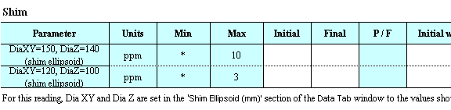Collect a shim data set as described in the Magnet Shimming Guide (DOC0934730). Run the Gradient Shim function before starting the image shim protocol and collect the data with the gradient shims applied.

Figure 3-8 Shim Ellipsoid Settings

- 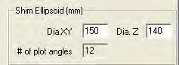In the Shim Ellipsoid field of the shimming application Data tab window, set DiaXY to 150 and
DiaZ to 140 (see Figure 3-8).
- Click Calculate.
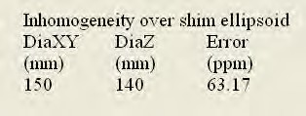Figure 3-9 Shim Ellipsoid Error

- Read the error value shown under Inhomogeneity over shim ellipsoid in the shimming application (see Figure 3-9). Record the value in the Shim table of the data sheet in the Initial with grad shims on column.
- Set DiaXY to 120 and DiaZ to 100 in the Shim Ellipsoid fields of the shimming application and repeat steps 2 and 3. (See Figure 3-8.)
- Collect another set of data for both shim ellipsoids with the gradient shims set to zero and record the values in the Initial column.
- If any of the values are out of specification, re-shim the magnet and record the final shim values.

The specification is that the error must be less than 10 ppm pk-pk in a 150 mm
diameter × 140 mm axial length ellipsoidal volume, and 3 ppm in a 120 × 100 mm volume.

- of 27

180mm RF Coil
This procedure characterizes the signal-to-noise ratio of the 180mm RF coil, and verifies the calibration of the transmit and receive chains.
Figure 3-10 180mm RF Coil Table

- 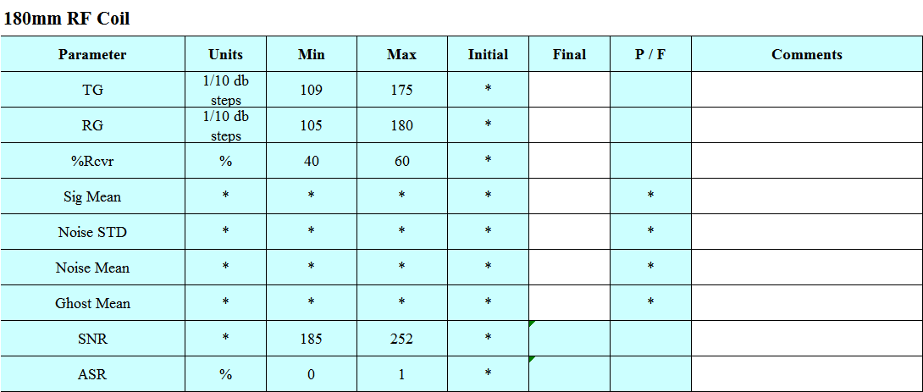Verify the following conditions:
  - The 180mm RF coil is physically undamaged.
  - The latch is working properly.
  - All screws are in place.
  - No connector pins are pushed in.
- Verify that the 180mm RF coil mates properly with the connector on the rear magnet plate.
- Insert the 180mm RF coil in the magnet bore.
- Place the DQA phantom in the Plexiglas holder and in the foam
sleeve. Place the phantom assembly in the magnet bore. Use the laser light to align the phantom.
- Select the Daily QA protocol, set the Prescan Mode to Manual Prescan, and click Begin Protocol.
- In the Manual Prescan window, run Auto Prescan with the Center Freq option set to Peak, then perform the Gradient Shim
procedure.
- Record the displayed Transmit Gain and Receive Gain values in the data sheet 180mm RF Coil table.
- Record the values for X shim, Y shim, and Z shim in the Final column. (See Figure 3-7.)
- Record the magnet center frequency in the Center Frequency & Gradient Shim table Final column. (See Figure 3-7.)
- Record the % of Receiver Full Scale value displayed in Receive Gain mode in the data sheet 180 mm RF Coil table.
- Select a result for center frequency in the data sheet Center Frequency & Gradient Shim table.
- Click the Save CF and Shim button on the manual prescan page.
- Click Proceed to start data acquisition.
- When the scan is complete, record the following values (ROIs and statistics shown on the image in Scan Display) in the data sheet 180mm RF Coil table:
- Signal Mean (IS)
- Noise STD (IN)
- Noise Mean ((left side mean + right side mean)/2)
- Ghost Mean ((top side mean + bottom side mean)/2)
- Verify that the image is annotated 180mm.

123mm RF Coil
This procedure characterizes the signal-to-noise ratio (SNR) of the 123mm RF coil. This procedure is also a system test that verifies the calibration of the transmit chain.
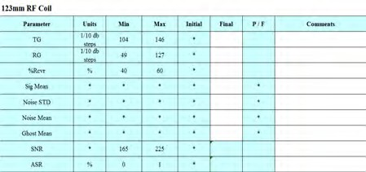Figure 3-11 123mm RF Coil Table

- Verify the following conditions:
  - The 123mm RF coil is physically undamaged.
  - The latch is working properly.
  - All screws are in place.
  - No connector pins are pushed in.
- Verify that the 123mm RF coil mates properly with the connector on the rear magnet plate.
- Insert the 123mm RF coil in the system.
- Remove DQA Phantom from the 180mm foam sleeve and Plexiglas holder and put into the 123mm foam sleeve.

- of 27

- Place the DQA phantom in the magnet bore.
- Select the Daily QA 123 sequence, or use the Daily QA protocol and set the following parameters:
  - Slice thickness:3.5 mm
• Freq: 512
  - Bandwidth: 50
- Set the sequence to Manual Prescan, and click Begin Protocol.
- In the Manual Prescan window, run Auto Prescan with the Center Freq option set to Peak, then perform the Gradient Shim procedure.
- Record the values for Transmit Gain and Receive Gain obtained by the prescan algorithm in the data sheet 123mm RF Coil table.
- Record the %of Receiver Full Scale value displayed when in Receive Gain mode in the data sheet 123mm RF Coil table.
- Click Proceed to start data acquisition.
- When the scan is complete, record the following values shown in Scan Display (on the image) in the data sheet 123mm RF Coil table:
- Signal Mean (IS)
- Noise STD (IN)
- Noise Mean ((left side mean + right side mean)/2)
- Ghost Mean ((top side mean + bottom side mean)/2)
- Verify that the image annotation indicates the 123mm RF coil.

Other RF Coils
For coils with a diameter greater than or equal to 160 mm, use the 180mm RF Coil procedure above to determine the parameters and fill in the appropriate coil table in the data sheet. For coils with a diameter less than 160 mm, use the 123mm RF Coil procedure above. For coils with a diameter less than 100 mm, use the 500 ml DQA phantom (2000-0013)

Magnet Monitoring Unit

Magnet Monitoring Functions
This procedure verifies that the critical magnet characteristics are being properly monitored and the results recorded. The CasWin tool measures the values being read by the 1.5T software. The procedure assumes that the files related to the CasWin tool are present in the Service Tools directory.

- Log in to the 1.5T application and enter Service mode.
- Click Service Tools, then click Free CAS.
- Click Service Tools, then click CasWin.exe. Remember to select viewing to see the CasWin tabs.
- Click the MMU1.5 tab.
- Click the Read All button.
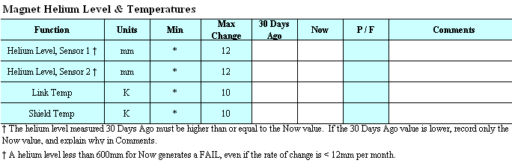Figure 3-12 Magnet Helium Level & Temperatures Table

- Use CasWin to read the helium level (both sensors), and record the values in the Now column of the data sheet Magnet Helium Level & Temperatures table.
- Use CasWin to read the magnet link temperature, and record the value in the Now column of the data sheet Magnet Helium Level & Temperatures table.
- Use CasWin to read the magnet shield temperature, and
record the value in the Now column of the data sheet Magnet Helium Level & Temperatures table.

- of 27

- Verify that the MMU voltage and heater continuity checks pass (OK appears next to MMU Power, Analog Power, and Quench Heater), and record proper operation in the Miscellaneous table of the data sheet.
Figure 3-13 Miscellaneous Table

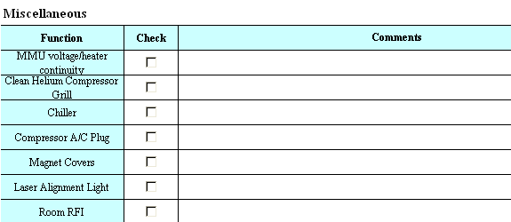

Figure 3-14 Magnet Pressure Regulator Table

- 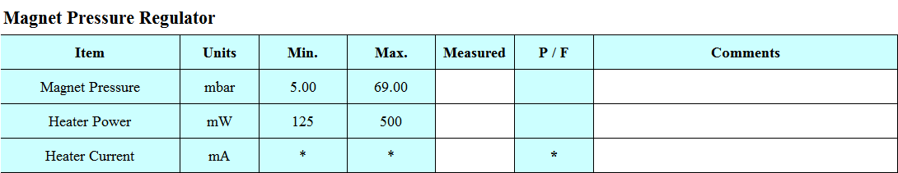Record the Magnet Pressure in the Magnet Pressure Regulator table of the data sheet.
- Record the Heater Power in the Magnet Pressure Regulator
table of the data sheet.
- Record the Heater Current in the Magnet Pressure Regulator table of the data sheet.

MMU Remote Functions
The MMU remote functions are configured and reviewed using CasWin. To check the MMU remote functions:

- On the CasWin MMU1.5 window, click Calibrate. (See step 1 through step 3 of Magnet Monitoring Functions on page 15 to open
CasWin.)
The Dialog window opens.

- Click Read All.
CasWin refreshes the fields in the Dialog window with the current values (see Figure 3-15).
- Verify that the Site ID (Site telephone number) is correct and check the box in the MMU table of the data sheet.

The Site ID is the phone number of the system’s modem.
Figure 3-15 CasWin Dialog Window

- 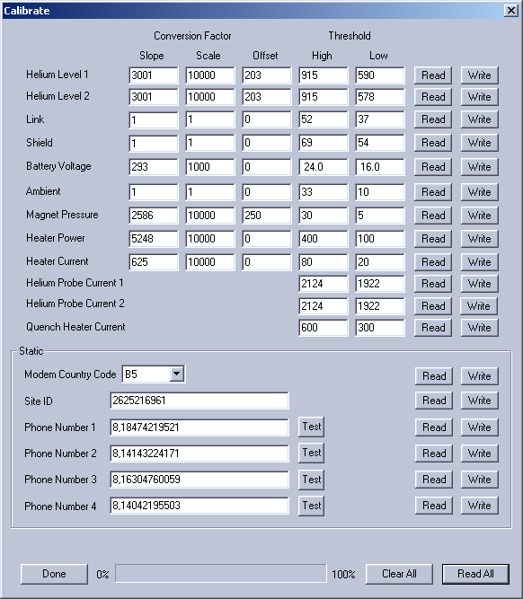of 27

- Verify that phone dial-out numbers 1 through 4 are correct and check the box in the MMU table of the data sheet.
- Check that Dial-out is enabled and check the box in the MMU table of the data sheet.
- Check that the battery is charged and record that the Battery Voltage is OK in the MMU table of the data sheet.
- Review the status area to make sure no errors are latched and check the box in the MMU table of the data sheet.
- Check that the MMU Battery switch is in the 1 position and check the box in the MMU table of the data sheet.
- Click the test button next to your phone number to test the call out function. (If your number is not in the list, temporarily change the number and click the test button.) If successful, record that MMU dials out properly in the Remote Access Testing table of the data sheet.
- Call into the MMU to test that the MMU receives calls properly and record in the Remote Access Testing table of the data sheet.
- If WebEx is installed, record this in the Remote Access Testing table of the data sheet.
- Exit CasWin.
- Select Reboot Scan Server from the Service tools list.

Helium Compressor

- Record the compressor dynamic pressure (when the compressor is running) in the data sheet Helium Compressor table.
- Record the compressor hours and the time of measurement in the data sheet Helium Compressor table. Check to see if compressor maintenance is required (refer to the Sumitomo manual).

Figure 3-16 Helium Compressor Table

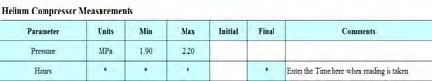

Figure 3-17 Miscellaneous Table

- Clean the air intake grille (refer to the Sumitomo manual). Record completion in the Miscellaneous section of the data sheet.
- Carefully feel the AC plug on the compressor power cord. An excessively hot plug indicates a poor connection, either in the plug or the outlet, that should be fixed as soon as possible to avoid the loss of compressor power. Record completion in the Miscellaneous section of the data sheet.

Miscellaneous
FA
LSE
FA
LSE
FALSE
Function | Check | Co
MMU voltage/heater
continuity
Clean Helium Compressor
Grill
Chiller
Compressor AC Plug
Magnet Covers
Laser Alignment Light
Room RFI

Gradient Chiller
FALSE
FALSE
FALSE
FALSE
Verify the following:
    - The temperature on the front of the chiller is 20 degrees C.
    - The pressure gauge on the front of the chiller is between 60 and 80 psi.
    - The coolant level is between the two lines on the front of the chiller reservoir.
    - The air filter is clean and does not need to be replaced. If the air filter is extremely dirty, clean it. If it needs to be replaced, refer to Chapter 2 of DOC0933217 FRU Removal and Replacement Guide.
    - There are no leaks in any of the hose connections. (Remove the rear cover of the magnet and open up the cable trough to verify there are no leaks.)
Check the Chiller box in the Miscellaneous table of the data sheet.

- of 27

Replacing the K-O Concepts Chiller Fan
Use this procedure to replace the K-O Concepts chiller fan. You should replace this fan every twelve months. A sticker should be placed on the front of the chiller during installation with the date the fan should be replaced. If the date on the front of the chiller is about three months from now, remember to order the part (1077-0009) for the next PM. If there is no sticker with a date on the chiller and it has been more than 12 months since the system was installed, plan to replace the fan during the next PM. You should update or add a sticker with a replacement date after each fan replacement.
- Verify that you have a K-O Concepts chiller (see Figure 3-18).

- Look for a sticker on the front of the chiller with wording stating that the fan should be replaced in three months.
- Do one of the following:
  - If you see this sticker, make a note to order part number (1077-0009) and you can replace the fan during the next PM.
  - If you do not see this sticker and it has been more than twelve months since the system was installed, you should order (1077-0009) and replace this fan during the next PM.
  - If you are performing PM and you are replacing the fan, refer to Chapter 2 of DOC0933217 FRU Removal and Replacement Guide.

Patient Chair

Hydraulic Systems and Levers
Figure 3-19 shows the location of the chair control levers, locks and brakes.

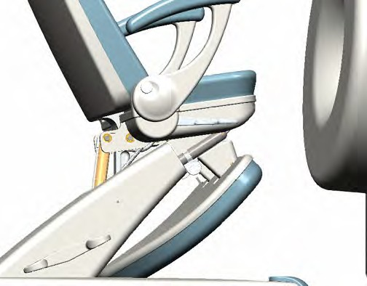Levers
Seat base lever

Seat back lever
Arm rest lock
Brake
Extension shaft
latch

Leg support release
The longer lever controls the seat back, and the shorter lever controls the base of the seat. The levers should be level with each other.
    - When the short lever is depressed, the seat base and seat back can be reclined in a fixed angular relationship to the base of the seat- this is normal.
    - The seat back and seat base should not recline until the control levers are depressed. If the chair reclines freely, one or both of the hydraulic assemblies has failed. The most likely cause is a valve stem failure in the upper or lower hydraulic system, and a new hydraulic assembly is required.
    - If the controls are not functioning properly, failure to line up may be caused by a broken valve stem.
Figure 3-18 Front of K-O Concepts Chiller

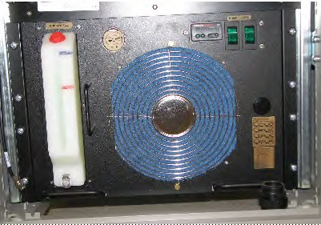

Figure 3-19 Patient Chair Controls

    - If the chair functions, mismatched handles are probably the result of a misplaced washer between the hydraulic valve and the buttock plate flange. The washers should be placed as shown in Figure 3-22 and Figure 3-23.

- of 27

Verify operation of the levers:
- Verify that the hydraulic systems and levers are functioning properly.
Levers are on both sides of the chair, below the armrests.
- Record proper operation of the levers in the data sheet Patient Chair
table.

- Verify that a limit screw is installed on the valve control mechanism for the upper hydraulic assembly, and that the limit screw contacts the underside of the buttock plate before the valve stem is fully extended.
- Remove the left and right underside covers and check the tightness of the screws holding the chair seat to the frame. Re-tighten if necessary.
- Record proper limit screw operation in the data sheet Patient Chair table.
Figure 3-20 Patient Chair Table

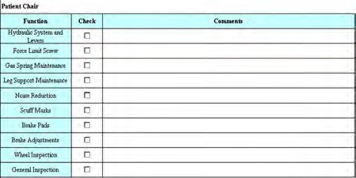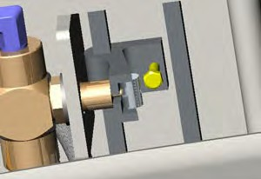Figure 3-21 Limit Screw
LLiimmiit ssccrreeww

Gas Spring

Testing Gas Spring Operation
This procedure tests the gas spring for proper operation.
- Press the long lever and push the seat back to the reclined position.
- Press the long lever, and verify that the gas spring brings the seat back to the upright position.
- Press the long lever and hold it down for several seconds, then release it.
Figure 3-22 Hydraulics, Right Side View

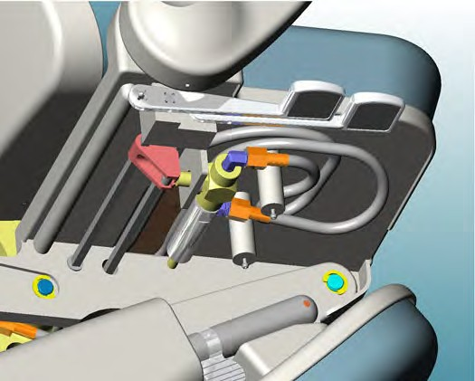There is more seat back movement in reclined positions. This is normal. Perform the next check with the seat back in the upright position.
BBuuttttoocckk ppllaattee ffllaannggee
Two washers here
Bearing in place

- Grasp the top of the seat back and move it forward and backward.
There should be less than one inch of total movement. If there is more than one inch of movement, air has entered the hydraulic system, and the hydraulic system must be replaced.

- of 27

Figure 3-23 Hydraulics, Left Side View

- 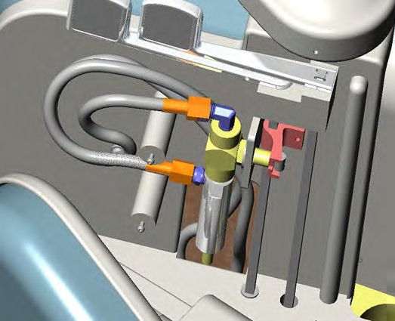Press the short lever, and move the seat base to the reclined position.
One washer here
BBuuttttoocckk ppllaattee
ffllaannggee
- Press the short lever, and verify that the gas spring brings the seat base to the upright position.
- Record proper gas spring operation in the data sheet Patient Chair table.

Leg Support

Testing the Operation of the Leg Support
- Pull on the leg support to check that the leg support slides in and out easily.
- Check that the leg support catches on the detents in the shaft.
- Record proper leg support maintenance in the data sheet Patient Chair table.

Leg Stability

Testing Leg Stability

Figure 3-24 Location of Four Bushings

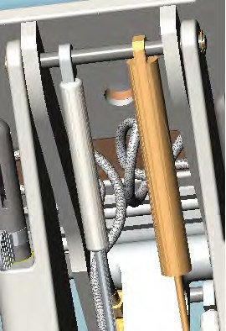1. While holding the left and right arms of the chair, move the chair from left to right, rapidly, to ensure the legs are not unsteady.
Unsteady legs are usually the result of bushings that have become dislodged in one or more of the four locations indicated in Figure 3-24.

Noise Reduction
Stick-on bumpers are installed on the brake pedals (see Figure 3-25), leg support (see Figure 3-25), and brake linkage (see Figure 3-26) to reduce noise caused by the chair's movable parts.
- Check to see that the bumpers are in place.
If any are missing, clean the appropriate areas and apply bumpers.
- Record the presence of all the rubber bumpers in the data sheet
Patient Chair table.
Figure 3-25 Leg Support Bumpers.

- 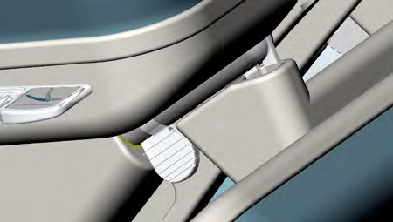of 27
BBuummppeerrss ttoo
rreedduuccee nnooiissee

Scuff Marks
- Use a cleaning solvent such as 409 to remove scuff marks from the lower castings around the brake pedals.
- Record scuff removal in the data sheet Patient Chair table.

Brake Pads
Eight brake pads are secured to the A-frame under the base casting by button-head screws.
Figure 3-26 A-Frame Brake Assembly and Brake Pads

Brake pad wear is a function of the number of chair brake cycles and operating environment. Consider
Casters
SSttiicckk--oonn bbuummppeerrss oonn eeddggee ooff
ccaassttiinngg cushion linkage
Brake ppaaddss
((44 ooff 8 sshhoowwnn)
the brake pad wear level relative to the date of last replacement when determining whether or not a brake pad requires replacement. You must replace a brake pad if the rate of wear indicates that it could wear to the point that it will render the chair brake ineffective prior to the next scheduled planned maintenance.
- Roll the patient chair gently onto its side on a rug or other soft surface.
- Verify that all the brake pads are installed.
If any of the pads are missing or worn to the point of impending failure, replace them. (See Notice above).
- Record presence of all the brake pads in the data sheet Patient Chair table.

Brake Adjustments
The brake mechanism is adjustable from underneath the A-frame. A pair of screws that lift the underside of the linkage bracket away from the A- frame adjust braking force.
If adjustment is required:
- Loosen the three locking nuts. (See Figure 3-27.)
- Tighten the two adjusting screws to increase the braking force, or loosen the adjusting screws to reduce the braking force.
As a rule of thumb, the edge of the bracket flange should be slightly (≈0.05 in.) below the bottom surface of the A-frame. Do not allow the brake mechanism to lift the rear of the chair off the ground, because the patient chair could rock, requiring excessive force to apply the brakes.
- Tighten the locking nuts.

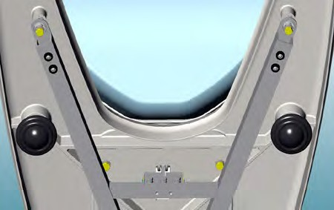screws
Locking nuts
Brake adjustment
Figure 3-27 Brake Adjustments

- Record that the brakes are properly adjusted in the data sheet Patient Chair table.

- of 27

Caster Inspection
This procedure verifies proper operation of the ball casters.
- Verify that all ball casters are intact and roll freely.
- Clean off any debris.
- Record that the casters are clean and operate properly in the data sheet Patient Chair table.

General Inspection
This procedure verifies the general condition of the chair.
- Perform a general inspection and cleaning of the patient chair.
- With both left and right covers off
- Verify that there are no physical defects.
- If any problems are found, correct them.
If it is not clear what action should be taken, contact GE Service support.
- Record satisfactory completion in the data sheet Patient Chair table.

Magnet Covers
This procedure verifies proper fit and condition of the magnet covers.

- Verify that the magnet covers fit properly in relation to the magnet, its individual pieces, the gradient coil, and the RF coils.
- Verify that there are no physical defects.
- Record satisfactory completion on the data sheet Miscellaneous table.

Figure 3-28 Miscellaneous Table

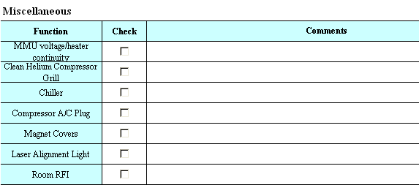Laser Alignment Light
This procedure verifies proper operation of the laser alignment light.
- Verify that the laser light switch turns the laser on and off properly.
- Verify that if the light is left on, initiating a scan turns the light off.
- Verify that the laser line projects properly. The distance of the laser plane from isocenter should be 5/8” (15.8 mm) from the front edge of the RF coil.
- Record satisfactory completion on the data sheet Miscellaneous table.

RF Interference
This procedure verifies that the system is not affected by RF interference.
- Verify that the exam room has standard incandescent light bulbs. Energy saving fluorescent light bulbs may cause significant RF interference.
- Install the 180mm RF Coil. Remove any phantoms from the coil.
- Use the Config File Editor to record the values of Valid_Space_Rmax and Valid_Space_Zmax.
- Turn off image masking by setting the Valid_Space_Rmax and Valid_Space_Zmax system configuration variables to 0.2.

- of 27

- Start the scanner in service mode. Select the RFI sequence. Select Manual Prescan and begin looping in Receive Gain mode. Adjust transmit gain to 120 and receive gain to 200. Set center frequency to a value 50 kHz less than the saved center frequency.
- Click Proceed, and verify that there are no perceptible RFI artifacts (zippers, coherent dots, etc.) in the resulting noise image.
- Increase the center frequency by 50kHz and repeat the scan, again verifying a clean image.
- Repeat step 7.
- Record satisfactory completion on the data sheet Miscellaneous table.
- Return the system configuration settings to the default values.

Cryogen Vent Inspection
Inspect the cryogen vent annually.
- Inspect the scan-room venting:
  - Inspect the flex hose and quench valve hose clamps.
  - Inspect the solid vent pipe for cracks or breaks.
- Inform the customer that it is time for the annual inspection of the vent pipe.

Image Quality
This procedure verifies proper image quality.
- Install the orientation phantom (Part #2000-0008) centered in the 123mm RF coil.
- Run the Image Quality protocol to characterize the image ghosting artifacts. If the protocol is not available, set up and run the sequences listed in Table 1.
Use the ghosting calculator available in the PM Data Sheet image quality table to calculate the ghosting percentage. The ghosting percentage is calculated by taking the difference of the means of the ghost intensity and the noise intensity divided by the mean of the signal intensity:
100 × (GhostMean – NoiseMean) ÷ SignalMean
TABLE 1. Image Characterization Sequences

Seq | Matrix | TR | TE | FOV | NEX | BW | ETL | slices | thick | gap | Orient | Freq
SE | 256x192 | 350 | 20 | 160 | 1 | 50 | - | 9 | 4 | 1 | Ax | L/R
SE | 256x192 | 1500 | 20/80 | 160 | 1 | 50 | - | 9 | 4 | 1 | Ax | L/R
FSE | 256x192 | 1500 | (min) | 160 | 1 | 50 | 8 | 9 | 4 | 1 | Ax | L/R
FSE | 256x192 | 1500 | (min) | 160 | 1 | 50 | 8 | 9 | 4 | 1 | Sag | A/P
FSE | 256x192 | 1500 | (min) | 160 | 1 | 50 | 8 | 9 | 4 | 1 | Cor | L/R
FSE | 256x192 | 1500 | 80 | 160 | 1 | 50 | 8 | 9 | 4 | 1 | Ax | L/R

- 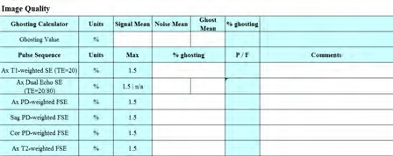Record the value for the slice in each set that gives the highest value
in the data sheet Image Quality table.

- of 27
Figure 3-29 Image Quality Table

Backup Configuration Files and Magnet History File and Remove Service Software

Backing up Configuration Files

The backup will be done through the command window. The BackUpconfig.bat file is loaded by the service tools CD. If the file is not available, re-load the service software.

- Log on as Administrator. Use the password smradmin.
- Go to the Start menu and select Run…
- In the Run popup window, type cmd and click OK.
- When the command window opens, type in net stop css
- Change the directory to c:\ and either delete the error log or rename the error log.
- Change the directory to: C:\Program Files\ONI\OrthOne\ServiceTools

The backupconfig file will by default save the configuration files to the c:\BackupTemp directory. To select another drive, input the drive letter.

- Type in backupconfig x, where x is the drive letter, to save the files onto a USB memory stick. You may also want to make a copy of the BackupTemp folder on the D: Drive. (type in backupconfig d)
- Label the USB memory stick with the site name and the date, and leave it with the site software.

Backing up Magnet History file
Copy the shim history file (located at C:\Program Files\ONI\OrthOne\ServiceTools\Magnet Data) onto the USB memory stick, label it, and leave it with the site software. The file format is: Magnet_[serial number].dat.

Removing Service Software
When the service is complete, you must run OniSvcToolUninstall.exe to remove the service software from the host computer. It is GE policy that all service software must be removed from the host computer before releasing the system to a customer. Leaving the service files on the host computer allows unauthorized changes to system parameters, and could have serious consequences.
To remove the service software:
1. In Service mode, select OniSvcToolUninstall.exe from the Service Tools menu. The .exe program removes the service files from the host computer.
For detailed information on the uninstall tool, see Installing and Deleting Service Tools.

Reporting
Send the completed PM data sheet to the following email address: SpecialtyMRmsk@ge.com.

- of 27

This page left blank intentionally.

- of 27

1.5T MSK Extreme Planned Maintenance

Index
Index

B
Brake adjustments, 21
Brake pads, 21

C
Chair, 17 Compressor
helium, 17
Conventions, 4

G
Gas springs, 19 Gradient amplifier
calibration, 11

H
Hydraulic systems and levers, 18

I
Image orientation, 11
Image quality, 23

K
K-O Concepts Chiller Fan replacing, 18

L
Laser alignment light, 22 Leg stability
testing, 20
Linear gradients, 12
M
Magnet covers, 22
monitoring unit, 15
MMU, 15

N
Navigation, 4
Noise reduction, 20

P
Patient chair, 17

R
Regulator, magnet pressure, 17
RF coil
123mm, 14, 15
180mm, 14
RF interference, 22

S
Safety, 5
Scuff marks, 20, 21
Sensaphone, 24 Service software installing, 11
Shimming, 13

T
Test conditions, 8

Helium compressor, 17
Reporting, 9
V
Vibration isolation floor, 23

- of 27

27

